Mathematical Association of Tasmania
2018 MAT Problem Solving Competition

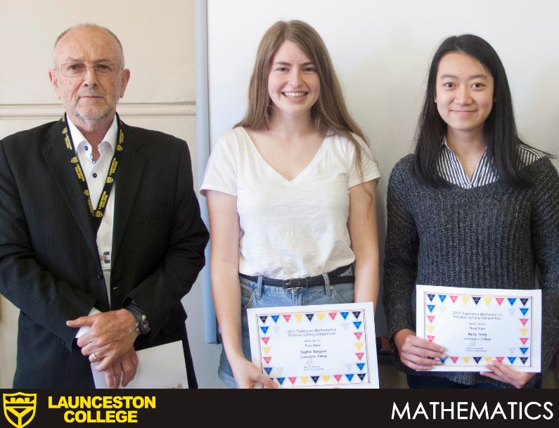
Principal Keith Wenn, Sophie Burgess (Senior Division, 1st Place, 2017) and Molly Deng (Senior Division, 3rd Place, 2017)

Thursday 22nd March 2018

DIVISIONS |  | PRIZES
Primary | Years 5 – 6 | 1st Place | $100
Junior Secondary | Years 7 - 8 | 2nd Place | $60
Upper Secondary | Years 9 - 10 | 3rd Place | $40
Senior Secondary | Years 11 - 12

Participation Certificates for all students
We recognise high-achieving Years 5, 7, 9 and 11 students as they compete against older students

Example Question
a) Write down the first ten prime numbers.
b) I picked two different prime numbers and multiplied them together. My answer
was 51. What were my numbers?
c) How many numbers below 51 do not share a factor with 51? (For example: 15 and
35 share a factor as they both divide by 5, while 16 and 35 do not share a factor.)
d) Pick two different prime numbers and multiply them together. How many
numbers less than your total do not share a factor with your total? Repeat.
e) I pick two more prime numbers: 3301 and 1030201. I multiply them together.
How many numbers less than my total do not share a factor with the total?

Entry forms and payment are due by
Friday 15th March 2018

